# 12/17/2021

IMMEDIATE RELEASE, Toms River, New Jersey MEDIA:

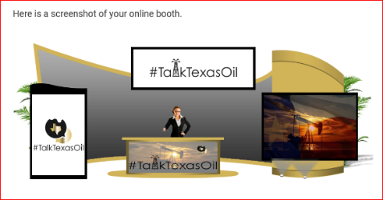

Kimberly Smith 432-352-6649

[talktexasoil@gmail.com](mailto:talktexasoil@gmail.com) talktexasoil.net

Press Release (Virtual Office)

While some regions of the United States have the luxury of warmth some communities fear being cold through the winter.  Many Northeastern families do NOT have the luxury of natural gas to warm their homes. They are also worried about being cold and the rising costs of utility bills this winter.  In response to this need and concern for families impacted by rising energy costs, fuel consumption increase, and the potential gas tax, energy broadcasters have **launched a 30-day crowdfunding campaign to help keep Upper NE Coast families warm this winter**. Families may be cold because of the lack of pipelines and natural gas infrastructure.  The Institute for US Energy states that “Northeast residents pay 29% more for natural gas than the average family in the United States.” The existing natural gas network is not enough to facilitate the spikes during the winter season. TalkTexasOil™ is providing a collective opportunity for individuals, associations, and companies to keep families warm during Winter 2022. **There are multiple ways to donate to help keep people warm!**

1) Donate through **Go Fund Me.** [**https://gofund.me/571548a**](https://gofund.me/571548a)

2) Send a check, clean blanker or coats to TalkTexasOil in the Upper NE Coast **- 1358 Hooper Avenue Suite D6, PMB 352 Toms River, New Jersey 08753.**Deadline - January 15, 2021

**Your donation will buy items to keep families in the Upper NE coast warm & support the #fossilfuel message.**    Our national media partners include **@TalkOklahomaOil,** (Oklahoma) **@TalkingEnergyShow** (Oklahoma)  Nationally, we understand the human impact of climate crisis legislation which halts the exploration and development of natural gas.    These outlets promote the significance of #fossilfuels through print, social media, and the You Tube channel **#fossilfuelfridays. The funds will be used for distribution of the supplies and fossil fuel message.** For more information contact **talktexasoil@gmail.com** or visit us on all social media platforms. Or #fossilfuelfridays on YouTube. **432-352-6649 - Kimberly Smith or 405-568-2742 - Matthew Hill** #redtapeonblackgold.  #talktexasoil #weareoilandgas #fossilfuelfridays  #talkingenergyshow #talkoklahomaoil