2021 DAPL Committee Member of the Year Award
Pam & Phill Cortese
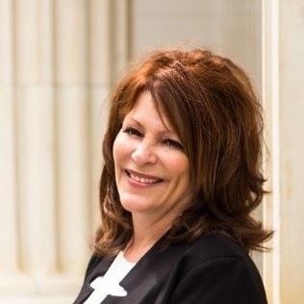
This years winner of the DAPL Committee member of the year award is going to someone who took on the heavy responsibility of organizing an event that has been cherished by the DAPL for many years. On a normal year, throwing an incredible Rockies Bash is a tall task, but as you all know, this year has been anything but normal. Not only did these awardees have to take into account that it was their job to throw a grand party, but they also needed to considerate the strange climate that we are currently in.
Although they were nervous in the lead up to the event, the party could not have been more successful. Not only did the 2021 Rockies Bash raise a substantial amount of money, but it was also heavily attended by DAPL members and by industry professionals who are not typically involved in the DAPL events. Over the course of the party, there were around 450 people in attendance. Everyone there had an amazing time catching up with friends and colleagues that many people hadn’t been able to see in the past 1.5 years.
These awardees are an integral part of the Denver oil and gas industry and have been for many years. If you have the pleasure of knowing them, then you know that we are grateful to have them represent our industry throughout the community. Their commitment to integrity and quality work is seen through their company, TCO Land Services, and the rave reviews they both receive from anyone who is able to work with them. Shown through their hard work that the Rockies Bash required of them, they are always anxious to volunteer, even if they know it’ll require an ample amount of their time.
Throwing the Rockies Bash is a huge undertaking, but these Committee Members were not intimidated. They are always eager to volunteer and we are so grateful that they did. This year, the Rockies Bash raised over $37,000 dollars in sponsorship and was an incredibly thrown event. These awardees wanted to throw one of the best bashes that the DAPL has seen and if you attended, I’m sure you saw that they were successful. Thank you so much for all your hard work and dedication to throw this amazing event. Everyone please join me in congratulating the 2021 Committee Members of the Year, Pam and Phil Cortese.

