2021 DAPL Landman of the Year Award
Gil Guethlein
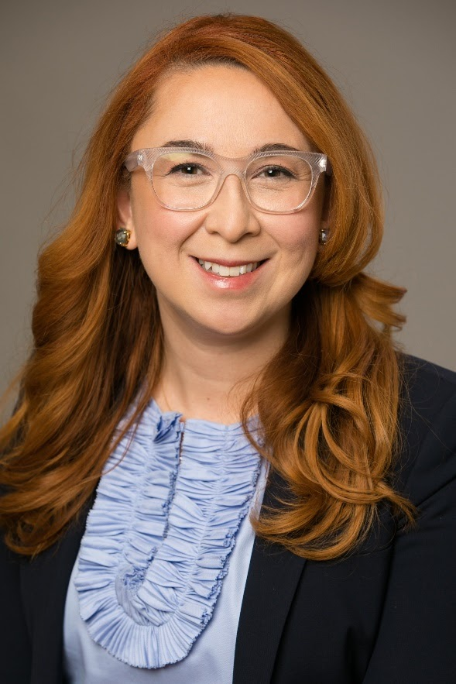

The 2021 Landman of the Year is someone who represents the oil and gas industry in a proud and progressive way. This awardee is passionate about volunteering her time and energy into the oil and gas industry and the Denver community as a whole. She has been on the DAPL Board since 2014 and her impact reaches far and wide. The 2021 Landman of the Year has been involved in the DAPL Networking and Ethics Committee and has served as the Secretary and Vice President of DAPL, just to name of few of her contributions. She is also an integral part of the DAPL sponsorship program and is always volunteering her time to maintain relationships with our sponsors. Not only is this Landman a huge part of the behind the scenes work at the DAPL, she has also given meaningful educational presentations at events like FLI.

Although the past year has been anything but normal, this awardee’s drive in her career has remained unchanged. This Landman is a CPL and is one of the best in the industry. As Land Manager of both the Texas and New Mexico assets at her company, she oversees approximately 47,000 net acres. This Landman tends to 49 vertical wells, 15 DUCs, 24 horizontal wells in the Midland and 1,200 producing wells in the Delaware basin. Not only does her job require continual maintenance of these existing wells, but she is also responsible for staying ahead of her company’s two rig drilling and completion program. This deserving awardee is known for her commitment to excellence in her career, but also known for maintaining quality relationships with everyone that has the honor to work with her. Her company and co-workers are grateful for all the ground that she covers on a day-to-day basis, and they truly value her drive and commitment to the success of the company.

As many of you know, the 2021 Landman of the year is highly regarded by all of her colleagues for passionately standing behind the oil and gas industry in the face of opposition, which is especially difficult (and common) in the Colorado Energy Industry. She’s also exceedingly philanthropic, frequently volunteering her time and talent to various organizations within the community. She's been an advocate for the oil & gas business by giving presentations to law firms and schools and served as liaison to the Latino community through roles with Latino organizations. This awardee also volunteers as a court-appointed special advocate children in the dependency and neglect system. She donates hundreds of hours to her community outside of the oil and gas industry and acts as a mentor to people in the industry. The scope of this Landman’s impact is so wide and the DAPL is truly indebted to her. Everyone please help me to congratulate our 2021 Landman of the Year, Gil Guethlein.

