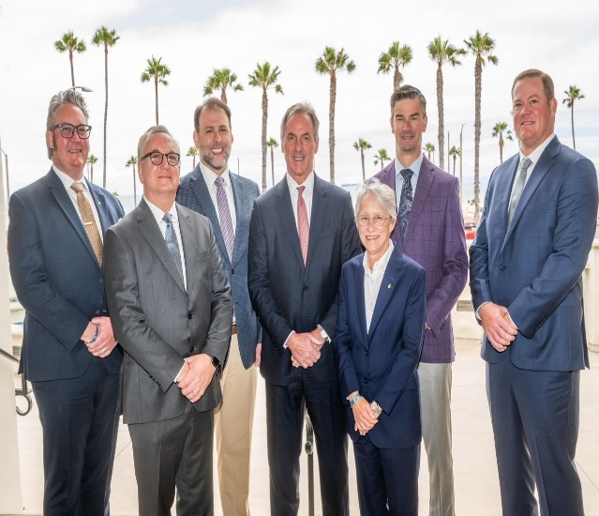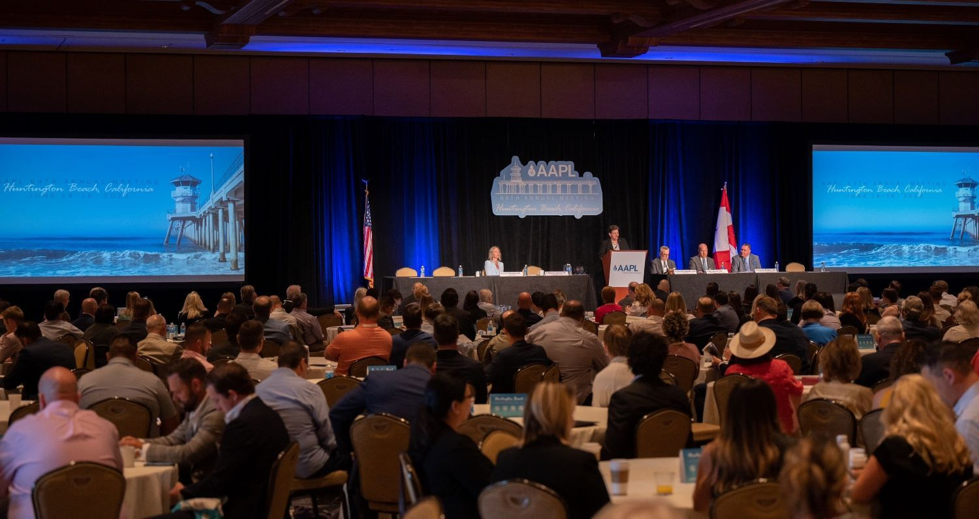

Director’s Update

June 2023

Tyler Aylor

FINANCE

AAPL remains in a strong financial position despite declines due to market activity. As compared to March 31, 2022, total assets have decreased from $42,339,817 to $37,355,925, a change of $4,983,892 or 11.8%. Decreasing membership levels as noted above have been met with increased discussion and action in reducing the operating expenses while maintaining the same level of current services and offerings to the membership.

The AAPL Board of Director’s Meeting was held on June 14th in Huntington Beach, California. This second quarter board meeting kicked off AAPL’s 69th Annual Meeting which included nearly 500 attendees, offered 17 continuing education credits, and welcomed in the new [Executive Committee](https://www.landman.org/about/governance/leadership?_zs=t15Xm&_zl=xHud2).

MEMBERSHIP

Total membership is up 0.51% from 2022 to

11,438 members, however still down 25.16% from 15,284 in 2020.

|  |  |  |  |  |  |  |
| --- | --- | --- | --- | --- | --- | --- |
|  |  |  |  |  | **2022-2023** | **2020-2023** |
|  | **2020** | **2021** | **2022** | **2023** | **% Change** | **% Change** |
| Active | 13,305 | 10,655 | 9,702 | 9,621 | -0.83% | -27.69% |
| Associate | 1,317 | 947 | 907 | 1,072 | 18.19% | -18.60% |
| Senior | 176 | 270 | 287 | 338 | 17.77% | 92.05% |
| Student | 486 | 364 | 484 | 407 | -15.91% | -16.26% |
| **Total** | **15,284** | **12,236** | **11,380** | **11,438** | **0.51%** | **-25.16%** |

GOVERNMENT AFFAIRS

As of the June meeting AAPL was tracking 429 bills, 88 Federal/State regulations and 30 Federal/State judicial cases. A full summary can be found on the AAPL website under [Advocacy and Legal](https://www.landman.org/resources/advocacy-and-legal).

Additionally, [AAPL Scores Big Win for Members With Passage of Our Sponsored Texas Landman Bill](https://www.landman.org/landnews/aapl-scores-big-win-for-members-with-passage-of-our-sponsored-texas-landman-bill). This is a great example of how AAPL works for all landmen whether they are members or non-members. While this was in Texas, AAPL can and will apply the same efforts in any state to protect the land profession. There is a Governmental Affairs Advocacy Request Form at the bottom of the Advocacy and Legal link above.

For the mutual good of the DAPL and AAPL and in the spirit of maintaining a strong relationship between our associations please contact me at [tyler@impactland.us](mailto:tyler@impactland.us) with any questions, concerns or suggestions.