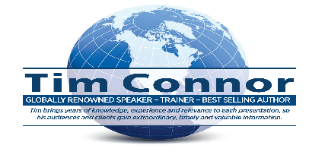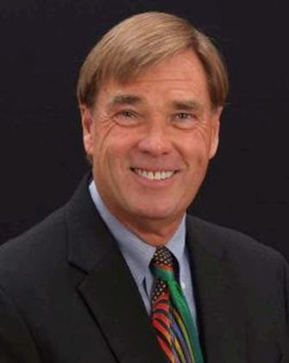

**What makes Tim one of the speaking profession’s most unique Global Speakers & Trainers;**

**-If you don’t feel he was one of the BEST speakers you have ever hired he will**

***Refund* the ENTIRE paid fee.**

**-He *Tailors* EVERY presentation to the audience and client profile, expectations and culture after “extensive pre-program research.”**

**Tim’s Background**

Over 90% of Tim’s engagements his entire career have been repeat requests from existing clients to speak on different topics. He has spoken at over 4000 meetings in 29 countries. He is a global bestselling author of over 80 books. He earned the CSP (National Speakers Assn. designation - Certified Speaking Professional in 1990). He has spoken in every state in the US and; **Argentina(4X), Australia(4X), Bermuda (1X), Brazil(3X), Bahamas(2X), Chile (1X), Canada(17X), Cayman Islands(2X), Dominican Republic(4X), England (3x), Estonia(3X), Guatemala(2X), Greece (3X), Hong Kong (2X), Ireland (3X), Indonesia(4X), Japan (2X), Mexico(3X), Malaysia(5X),** Kuala Lumpur **(3X),** **New Zealand, Paraguay(2X), Singapore(4X), Spain(2X), United Kingdom(2X), Uruguay(2X).**

**Tim’s Topics & Services**

He speaks on a variety of sales, marketing, management, leadership, business growth, employee development, communication, soft skills and emotional intelligence subjects. Regardless of its length each topic is tailored to the client and audience profile, expectations, culture, and industry after extensive personal research. He gives both keynote addresses as well as half and full day seminars and shorter workshops. He conducts numerous long-term custom corporate in-house employee development programs. He offers consulting, coaching, tele-coaching, and meeting facilitation services. He conducts custom webinars and offers numerous tailored materials such as manuals, profiles, evaluations, employee performance tests, etc. One of his most popular programs is his

"Employee Engagement Retreat Program" - an excellent and proven approach for maintaining employee and organization 'Peak Performance' behavior during uncertain and challenging times. His popular topics things like: The Kill switch – turn off life’s negatives - I dare you – find the courage to live – How mental cobwebs have a negative impact on every life area - Turning negativity into positivity and - Don’t let life’s stressors destroy organization performance.

**Tim’s Presentation Style**

If you want a speaker who makes you feel like you have just had a warm bath and life is good and will always be so – he is not your guy. Tim is one of very few unique, impactful, and successful speakers over the years who deals in common sense and reality. If you are looking for “pie in the sky” crap regardless of the topic he will make you feel uncomfortable. Positive change doesn’t happen in your business, career, or life until you get out of your comfort zone. His purpose is simple - if you want better, new or different something has to change or improve. And these will not happen as long as you stay in mindsets, approaches or philosophies that are not working. He is respectful and compassionate but political correctness is not his style. He does not preach. He does not have the right to tell others how to live but he shares his messages, regardless of the topic, in an engaging, entertaining, and thought-provoking way. One minute you will be laughing like crazy, the next one shaking your head thinking “this guy drives me nuts” and the next one taking notes like a lunatic, but in the end, you will be glad you heard his message – every word. He always arrives the day before he speaks and leaves the day after. All of his handout materials are also tailored to the audience profile and the topic.

**Tim’s Clients**

He has given over 2000 State and National Association presentations and 2500 corporate events in 29 countries and every state in the US. A few of his clients include NAHB, International Sign Assn. Snap-On Tools, National Drilling Assn., Stewart Title, PA. Assisted Living Assn., PBA Health Pharmacy Assn., VA Realtors Assn., NJ Government Finance Officers Assn., Northwest Cascade, The Int’l Truck Parts Assn., numerous NACE, SHRM, PMI and HIDA state chapters, and this list goes on and on . . .

**What a few clients have to say about Tim**

*“We have been hiring hundreds of speakers for conferences for over thirty years. Tim was* ***one of the best****. He was engaging, entertaining, and relevant with his messages*.” – President, PBA Health Pharmacy Assn.

“*WOW is all I can say about Tim. He was* ***engaging, relevant, and entertaining***.” Vistage Chair.

“*Tim has presented for the Building Systems Council over 10 times during the past 12 years.****He is the only speaker we have ever used in such high demand***.” National Assn. of Home Builders.

“*We have used Tim on multiple occasions for sales and management training over the years.* ***He always over-delivers*** *and gives our employees information, ideas, and techniques that have helped us consistently grow our business*.”  VP Sales, Minnesota Exteriors.

*“I heard Tim speak at our conference and I felt like he was talking directly to me and not just to the audience.* ***What he said made so much sense*** *that I decided to hire him for some custom in-house employee development training sessions.”* President, K&R Truck Sales.

“*Tim gave several sales and management presentations to our convention attendees over five days and****he hit it out of the park with every one of them***.” Regional VP, Snap-on Industrial Tools.

**Tim’s Fee & Services Overview**

**-If you would like his Corporate or Association detailed fee structure and benefits, just give him a call or send him an email – see below information.**

-His fee is for any portion of a day – multiple sessions on different topics if desired.

-Program fees for engagements within 120 days are due in advance of his

presentation. For engagements scheduled beyond 120 days a 50% deposit is due once

a date has been confirmed & the balance is due 30 days before the engagement.

-If you don’t feel he was one of the best speakers/trainers, you have ever hired - he will refund the fee!

-He gives every meeting participant (2 FREE eBooks - 20 to choose from - a $50/person value).

-There are no refunds for canceled programs – he will reschedule canceled programs for up to 12

months for no additional fee. If he is unable to honor his contract for ‘personal reasons’

he will give you a full fee refund.

**Tim Connor, CSP – (704) 875-1230 -** [**Timspeaks4u@gmail.com**](mailto:Timspeaks4u@gmail.com)[**www.timconnor.com**](http://www.timconnor.com)