**2020 DAPL Education Award**

**Bresee Carlson**

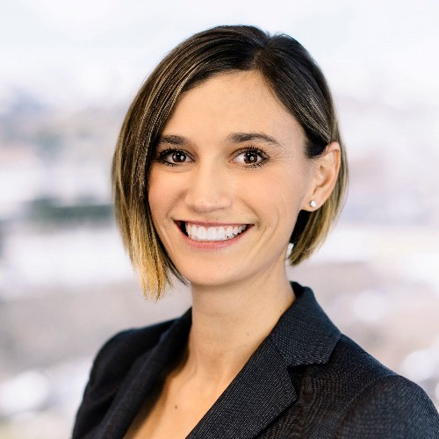

This year’s Education Award Winner, Bresee Carlson, is known by all of her colleagues to have a passion and commitment to the education of her colleagues and to industry outsiders alike. Carlson plays a key role in the DAPL as the Education Committee Co-chair. Carlson works tirelessly to set up monthly DAPL luncheon topics, ensures members’ AAPL and CLE credits are maintained, organizes fantastic speakers, and handles all logistical details like finding new spaces for the DAPL to use for education events and maintains the DAPL contractual obligations to these spaces, and more. Not only is Bresee’s work imperative for the DAPL to run smoothly, she is also an active participant in DAPL events and has even presented for the DAPL on topics like “Nuts and Bolts of Federal Minerals” and “An Overview of Royalty Payment Accounts.”

Currently Bresee is a Partner at Kuiper Law Firm, although her “extra-curricular” volunteering could be considering another couple of jobs in and of themselves. Since Bresee isn’t a Landman by training or occupation, the amount of time and work she contributes to the DAPL and to the oil and gas industry as a whole is even more amazing. This fact shows her willingness and commitment to interact with and promote the industry.

Outside of the DAPL, Bresee has recently accepted a position as a professor at Western Colorado University in their Energy Management Program. Bresee plans to restructure the curriculum to make the content accessible for students and to help maintain a strong AAPL accredited program. Also, because she wasn’t busy enough, Bresee recently became a Board Member of *Energy Strong*, a foundation whose mission is to unify blue and white-collar workers throughout the oil and gas industry, and to educate others about the benefits of the advancement of natural resource exploration and extraction the US.

Bresee Carlson’s work throughout the industry has been monumental, especially during a year where so many road blocks presented themselves. Despite these challenges, Bresee’s creativity and passion for the energy industry helped the Education Committee hold monthly virtual luncheon’s and led a informative Fall Land Institute Webinar Series. Bresee Carlson’s contribution to education, not only through DAPL, but throughout our entire community, has been critical for many years, and because of this, no one is more deserving of the 2020 DAPL Education Award.