**2020 DAPL Lifetime Achievement Award**

**Colleen Kennedy**

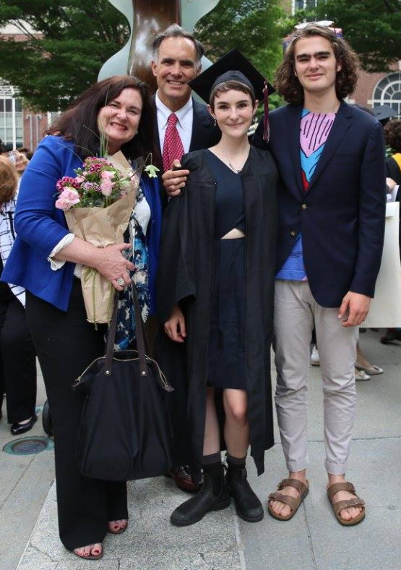

The 2020 Lifetime Achievement Award Winner, Colleen Kennedy, got her start in the oil and gas industry in the 1980’s at Amaco Production Company. As a Denver native and a graduate from the University of Colorado, she was excited to make a name for herself as a Landman in her hometown, and she did just that. Even in the male dominated field that was the oil and gas industry was in the 80’s, Colleen was determined to succeed and remains one of the top Land Professionals in the Denver area.

After working at Amoco for 15 years and gaining expansive knowledge in various Rockies basins, she moved onto other Denver companies, like Presco Western LLC and Bill Barrett Corporation, where she consistently proved herself as a tremendous leader and mentor to everyone who got the privilege to work alongside of her. As the Land Manager for many different areas including the DJ, Appalachian, Williston and Powder River Basins, Colleen always ran her assets efficiently by problem solving and guiding her teammates with steadfast leadership.

Colleen Kennedy has been apart of many notable deals in the oil and gas industry, in which she always utilized her dedication to precision so that the job would always be done the right way. Colleen managed several multi-million-dollar dispositions in the Rockies region and maintained critical relations with the MHA Tribe to efficiently develop assets in the Fort Berthold Indian Reservation. Most recently, Colleen lead her team at Occidental Petroleum Company to close a $1.33-billion-dollar deal with Orion Mine Finance, in which Oxy divested assets in Wyoming, Colorado and Utah. This key sale was a major contributor to Oxy’s 2020 target of $2 billion dollar plus in divestments over the year. Her co-workers were grateful for her leadership and knowledge during this massive sale.

Colleen is not only known for her skills in the Land Profession, but she is also known for her caring nature towards everyone she works with. Colleen is one of the greatest team players, in every sense of the word. She will guide you through any problems you may be faced with, work-related or not. Colleen is loyal and one of the best mentors in the Denver area. Colleen employs the perfect mixture of encouragement and tough-love to challenge you to be the best person and employee you can be.

Colleen Kennedy has worked hard throughout her career to leave a legacy of honest, good work. Throughout her career she became known for doing the dirty work. She has never backed down from a problem and has always finished the job the right way. Anyone who has been lucky enough to work with her has been impacted greatly by her positive attitude, passion for the industry, and her unwavering integrity.