**2020 DAPL Community Service Award**

**Janet Rost**

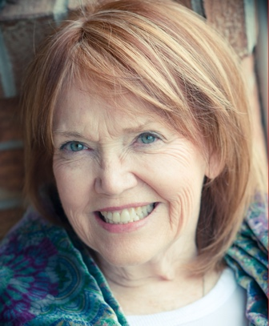

Janet grew up in the oil industry, daughter of a Texas A&M Petroleum Engineering graduate who started his own operating company in Houston, Texas. As a young girl, he would take Janet and her sister to West Texas to visit well sites. She went to University of Texas and studied Architecture. She was married to a landman who moved her from Texas to Denver in 1978 and there she accidentally ended up in the oil business to fill in as a draftsman in the land department of a Hunt family oil company, Impel Energy. The switch from architecture to land and geological drafting work was an easy decision since it paid twice what architectural drafting paid at the time. She ran a successful oil & gas drafting company for 20 years and through her connections in the industry, she worked her way into being a landman when her son went to college in the 2004.

She is unique in that she’s always been an independent landman working directly for many companies both in house and in the field. The list includes Great Western Oil & Gas Co., Anadarko Petroleum, EOG Resources, SRC Energy, and Liberty Oil Company among others. She’s worked for numerous brokers and managed to stay busy for many years in every basin of the Rockies and the Southwest.

She serves on the Regulatory/Advocacy Committee and the Education Committee, she is the past Treasurer of the Executive Board and is now a co-chair of the Finance and Planning Committee of the DAPL. Janet is a fierce advocate of our industry and our jobs.

The environmental movement has changed the narrative on our future and our industry has been under attack with the false Climate Crisis mantra. Becoming informed of the reality of what ‘keep it in the ground’ will do to our economy and ways of life has been a longtime mission for Janet, spending the last 15 years learning about the impacts of energy and fighting to keep our industry alive. She started educating her friends and anyone who would listen to her about why we need oil and gas, why fracing isn’t bad, why we need to keep the small independent companies going, and how this industry is a vital part of our economy.

Writing letters to her representatives during all the legislative battles of recent times, manning phone banks along with roomfuls of industry people to get out the vote, using social media to educate people who think we should stop producing oil and gas entirely. She has met with her state representatives to share her knowledge of why we are an important part of our state’s healthy economy. She worked especially hard testifying to our state legislature against 181, writing letters almost daily to representatives, talking to people on the streets downtown in defense of our industry, and testifying to the COGCC in many meetings on the positives of our industry and why we cannot let it be legislated away.

Janet has been committed to helping the community around her for the past 15 years and continues to be an example of how members of the oil and gas industry should go about creating the change that we want to see in our state.