2021 DAPL Hall of Fame Award
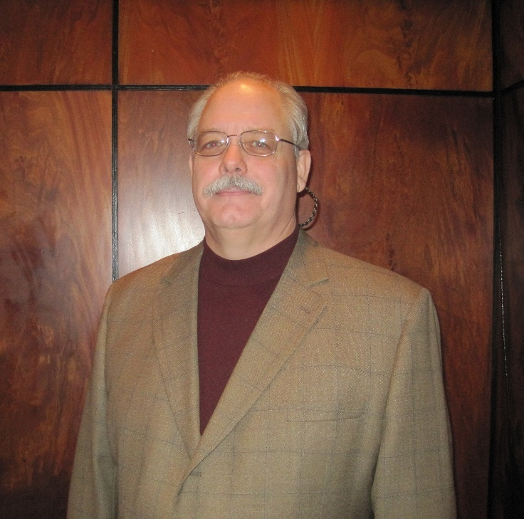
John Hasche
The 2021 Hall of Fame Award Winner, John Hasche, was born and raised in Glendive, Montana. He graduated in 1974 from University of Montana with a degree in Geography. The same year, he began career in Denver with Amoco Production Company, putting his undergraduate skills to use in their map drafting department. In 1976 he made the move to the land department at Amoco, and there was no looking back from there. Throughout his prosperous career, he was a Landman and manager for Amoco, Western Gas Resources, Inc. and Anadarko Petroleum Corporation, where he worked various assets in the Rockies region. Now partially retired, Hasche is still an active member of the Denver Land community. Hasche is heavily involved in mentoring the younger generation of up-and-coming Land professionals. Since the inception of Western Colorado University’s (WCU) Energy Management program in the mid-2000s, Hasche has facilitated countless partnerships between industry professionals, energy educators, and students. He has served as a Member on the WCU Advisory Board since 2008. His time and resources spent on the development of this program and spreading land education while at the height of his career at Anadarko and afterward are invaluable. Since then, he has spent countless hours mentoring students from WCU and young industry professionals in Denver interested in energy and land-based careers.
Hasche’s experience in the Rockies region exposed him to managing assets in a variety of basins. While at Amoco, he oversaw much of the land operations in the San Juan Basin. In this role, he managed a multi-discipline team of engineers, land negotiators, and land administrators. He also led Amoco’s successful defense in the Southern Ute Reservation litigation, valued at saving up to $500 million in settlement costs. He left Amoco in 1999 after the merger with BP. In 2006, Hasche joined Anadarko where he worked as a Senior Staff Landman and Land Project Advisor until the merger with Oxy in 2019. During his tenure at Anadarko, he managed assets in both the Greater Green River Basin and the DJ Basin, where he became a subject matter expert on the Union Pacific Land Grant mineral ownership.
Hasche is also active in giving back to the Denver land community through the DAPL. He was president of the DAPL from 2009-10 and spent many years as the Education Committee Co-Chair. He is currently a mentor in the John L. Hunt Mentorship Program, a DAPL sponsored group that links young land professionals just starting their careers with older more experienced industry veterans such as himself. The mentorship program is just one of many ways that he continues to come up with new ideas to give back through his achievements. For over forty years, he has been a pillar of leadership in the Denver Land community.
When he is not keeping busy with his many philanthropic pursuits, Hasche enjoys spending time at his second home in Gunnison with his wife Kitty, golfing, shotgun shooting, fly fishing/tying, and cowboy movies (particularly those with John Wayne).
Please join me in congratulating John Hasche on being this year’s Hall of Fame Award winner!

