January 10, 2021

**RE: Nomination Letter for Jason Maloy**

To Whom it May Concern:

I am writing this letter to nominate Jason Maloy for the AAPL’s Landman of the Year Award. I have known Jason for approximately eight years. We met when I served as his intern during my first internship at Encana Oil & Gas (USA) Inc. in the summer of 2013. Since then, I have collaborated with Jason on the AAPL Accreditation Committee, and he has served as a mentor to me.

Jason has held countless positions within the AAPL and is a strong advocate for the AAPL to universities nationally. Although he is no longer on the Accreditation Committee, Jason is always available for questions and still provides a tremendous amount of support to our committee. Jason is selfless with his time and has made considerable contributions to our industry. He has visited countless universities to enlighten students about the landman profession and has supported many scholarship and teaching initiatives.

I recommend him with the highest degree of enthusiasm.

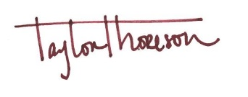Sincerely,

Taylor Thoreson

Land Manager – Business Development

Legacy Reserves Inc.