**2020 DAPL Landman of the Year**

**Matt Smith**

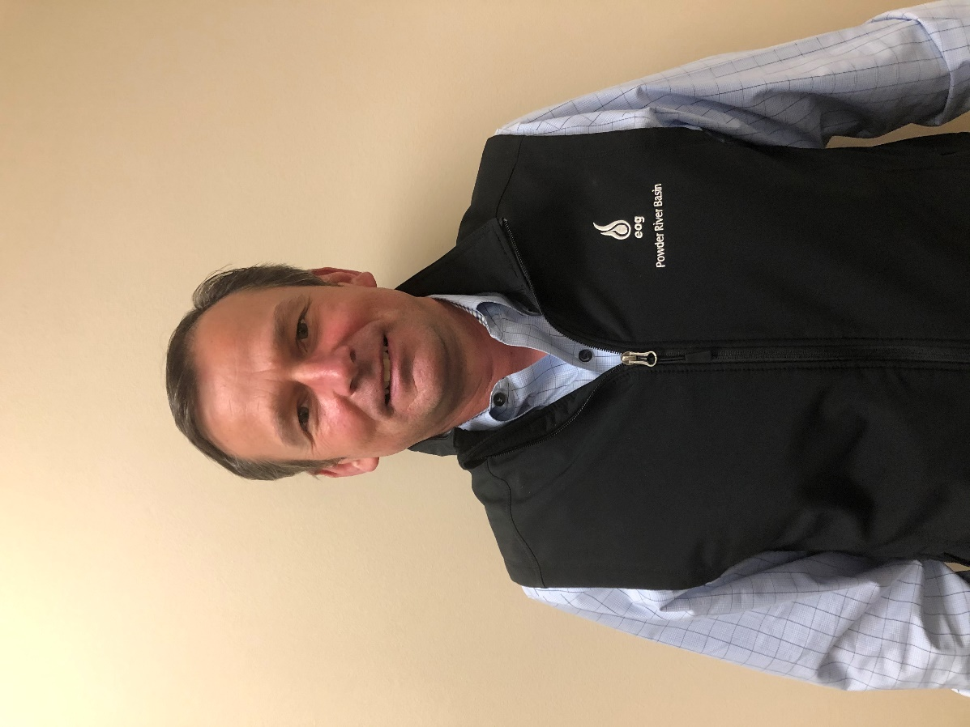

The 2020 Landman of the Year, Matt Smith, got his start in the oil and gas industry in 1996, when he began his career as a Field Landman after graduating from Texas Tech University. In 2001, he took a job with El Paso Production in Houston, Texas as an in-house landman working the Gulf Coast of Texas. He left El Paso Production in 2003 to work as a Field Landman. In 2005, EOG Resources, Inc. hired Matt as a Landman to work in the Fort Worth, Texas Division Office and since then they couldn’t get rid of him. In the past 15 years, EOG Resources has recognized Matt’s hard work and dedication to the industry and has moved him across the country multiple times.

Matt has been an active member of American Association of Professional Landmen (AAPL) since 1998 and became a Certified Professional Landman in 2005. Matt currently serves as a Director for the Denver Association of Petroleum Landmen and is a Trustee for the AAPL Landman Scholarship Trust. From 2018 to 2019, Matt served as a Committee Chairman for the AAPL Industry/Public Relations Committee. From 2015 to 2017 Matt served on the AAPL Membership Committee as Assistant Chairman and Chairman and from 2012 to 2013 he served as Treasurer on AAPL’s Executive Committee. He served on the NAPE Operator’s Committee from 2011 to 2012, the AAPL Education Committee from 2011 to 2012 and served as a committee member for the AAPL Southwest Land Institute from 2007 to 2012. He served on the AAPL Certification Committee from 2006 to 2011, the last two years as Assistant Chairman and Chairman. Matt is a past member of the Fort Worth Association of Professional Landmen (FWAPL). He was a member of the FWAPL Executive Committee, Chairman of the FWAPL Scholarship Committee and served on the Golf Tournament Committee and Skeet Shoot Committee. Matt is also a member of the Houston Association of Professional Landmen.

In 2018, Matt moved to Denver, Colorado to serve as the Division Land Manager for the Western U.S. and Canada. Since arriving in Denver, Matt has been committed to connecting with new colleagues in the industry and serving the oil and gas community here. In his short time in Denver, Matt has made a great name for himself. He is known by his coworkers as a talented leader who is very skilled in his position and “treats work like war” (-anonymous co-worker). When coming to a new city, it’s easy to take a back seat and go unnoticed, but Matt became involved with the DAPL as soon as he made the move. Unfortunately for us, Matt’s home state of Texas has recently called him back home. EOG Resources moved Matt to Midland, Texas to serve as the Division Land Manager for the area. Matt’s commitment to his community and the oil and gas industry as a whole will be missed greatly by the DAPL, but Midland will be lucky to have his expertise and energy.

*“It is an honor and privilege to be named DAPL’s Landman of the Year.  In my short time in Denver the DAPL has been a great resource for networking and educational opportunities.  The members of DAPL are not only welcoming but they are professional people that want what’s best for the organization and our industry.  Thank you for this honor.” -Matt Smith*