**Student/Resident Verification Form**

This letter is to confirm that Mr./Ms. **Renga Samy** is a currently Studying Energy Undergraduate Student in my Student/Residency/Fellowship/PhD Program at: **California State University** doing Phd Program In **Oil & Gas** Field Research.

He need some network connections related to Energy industry reference we are referred Energy related associations.

His/her Student/residency/fellowship training dates are the following:

From: 06/25/2019.

To: (Anticipated Completion Date):06/30/2022.

Advisor’s Full Name: Stefan Watson

Advisor’s Email Id: <stefan@newsatllc.com>

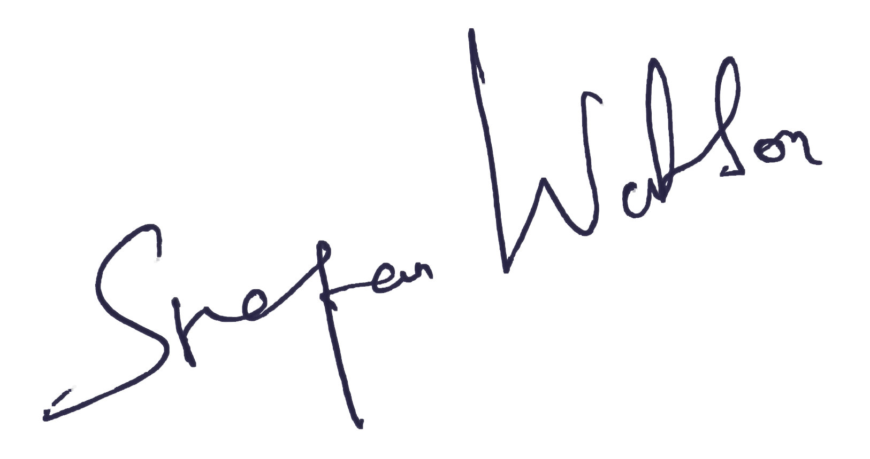

Signature of Director of Current Residency/Fellowship Program