Dustin D. Rucker

3220 West Shandon Avenue • Midland, TX 79705

dustinrucker@gmail.com • (432) 528-4914

December 4, 2024

To Whom It May Concern,

I am writing you to nominate Will Porter for the AAPL Lifetime Achievement Award for the upcoming year. Will has been the gold standard for the profession for decades, not only in the Permian Basin but across the country. When thinking of someone that embodies what it means to be a Landman, to be someone of the highest respect and integrity, and to be someone that wants to see the next generation of Landmen succeed, Will Porter is unquestionably the person that most exemplifies those traits.

Will has been an active member of the Permian Basin Landmen’s Association for 40 years, and in that time has been one of our most active members. He has contributed an unbelievable amount of time at a local level to see the growth not only of the PBLA, but also growth of the profession. Will has served in a variety of positions on the PBLA, most notable as the President in 2008-2009. Will has seen the industry go through the ups and downs throughout his career but has always been someone that other Landmen can go to through tough times.

Will has always been an active member with the AAPL. He has served on numerous committees and position with AAPL and has always been an advocate for being involved at the national level. Will sees the value in being involved, being a good team member, and bringing together others for the greater good of the profession.

Personally, Will has been an incredible mentor. He has always been a respected sounding board when I have questions in my day-to-day tasks and has always been a willing teacher when questions arise. When the PBLA was going through a large transition the past few years, Will was someone we relied on to guide us through our struggles, as we were a very young and inexperienced board. His guidance was needed and because of that we have seen our organization grow tremendously.

I see no one better to receive the Lifetime Achievement award than Will Porter. I hope you will take him into consideration when looking for an individual that most exemplifies the characteristics needed to be a successful and respected Landman.

Thanks.

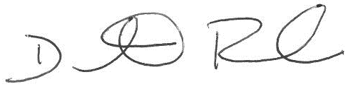

Dustin Rucker